

**OUR ROOMS**

All beds can be separated or joined together, depending on the needs. Rooms are equipped with cotton sheets and towels.

Three suites in cottages (around 50sq.m) offer each a double bedroom with a private bathroom, a living room, a kitchenette, and a private terrace

Three luxury rooms (around 25sq.m each) with private bathroom, are located in the main building, above the Yoga room.

The other six double rooms, with shared bathroom – one every two rooms – are located in three cottages (around 60 sqm each) in the garden, all with their own equipped private patio and a kitchenette. Each cottage has two double rooms, one of which is separated by colourful heavy curtains, which can be open to create a large common area.

All rooms have heating and air conditioning facilities and are elegantly furnished with antique or Sicilian style furniture.

**For any further information write to: info@sicilianspirit.com**

**LUXURY ROOMS**

**THE BLUE ROOM**

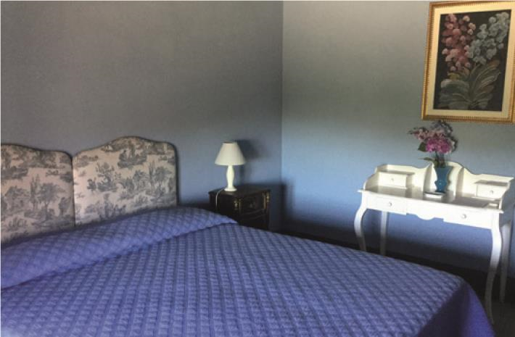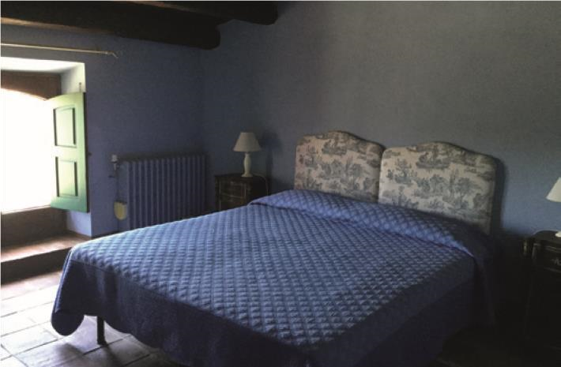

It is located on the first floor of the main house. Intimate and romantic, furnished with antiques furniture, the Blue Room is particularly suitable for couples or singles. It has a private bathroom and offers an enchanting view of the courtyard of the Masseria and the fields. It has in room Wi-Fi service.

**THE**

**GREEN**

**ROOM**

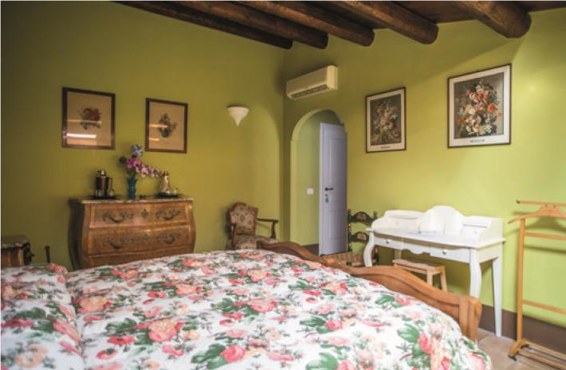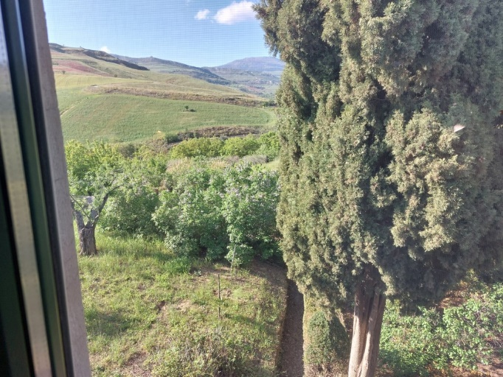

Extremely quiet and placed in front of the Blue Room, the Green Room is furnished with antique Sicilian furniture, has a beautiful view on the countryside and a private bathroom. Particularly suitable for couples or singles. It has in room Wi-Fi service.

**THE YELLOW ROOM**

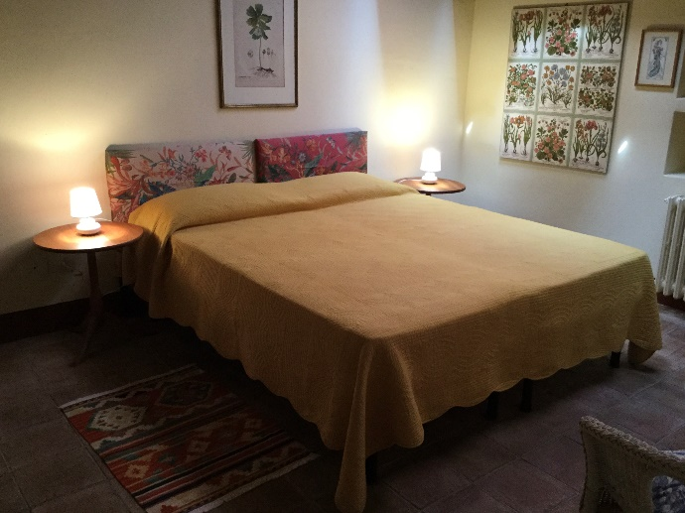 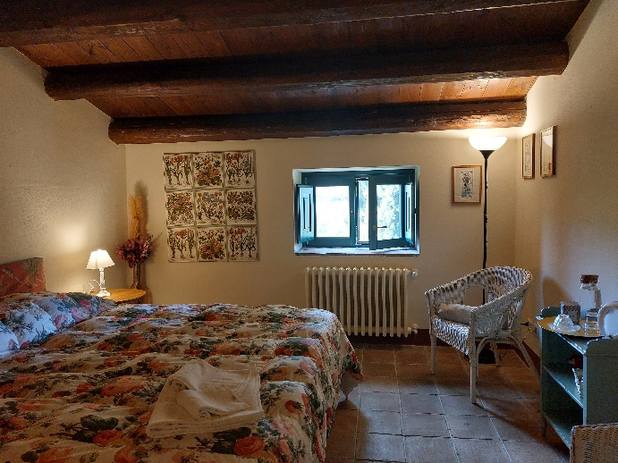

Twin to the Green Room, and as well extremely quiet and placed in the main building, in front of the Blue Room, the Yellow Room has also a beautiful view on the countryside and a private bathroom. Particularly suitable for couples or singles, it offers in room Wi-Fi service.

**SUITES**

**SUITE LABIRYNTH GARDEN**

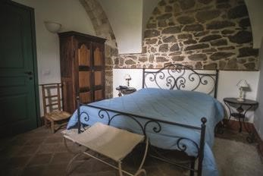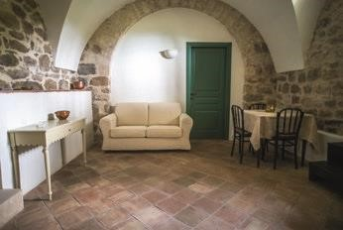

Living

room



Lobby



Bedroom



Bath

Around 80 sq.m. large, the apartment offers a ground terrace for exclusive use, adjacent to the historic garden, a double bedroom with bathroom en-suite, a living room with sofa bed and an entrance hall.



**SUITE CONIGLIERA**

**A**

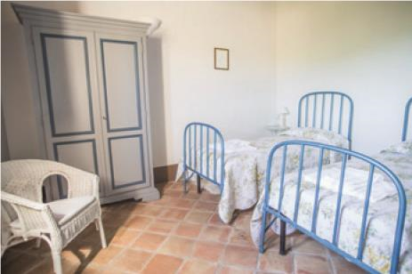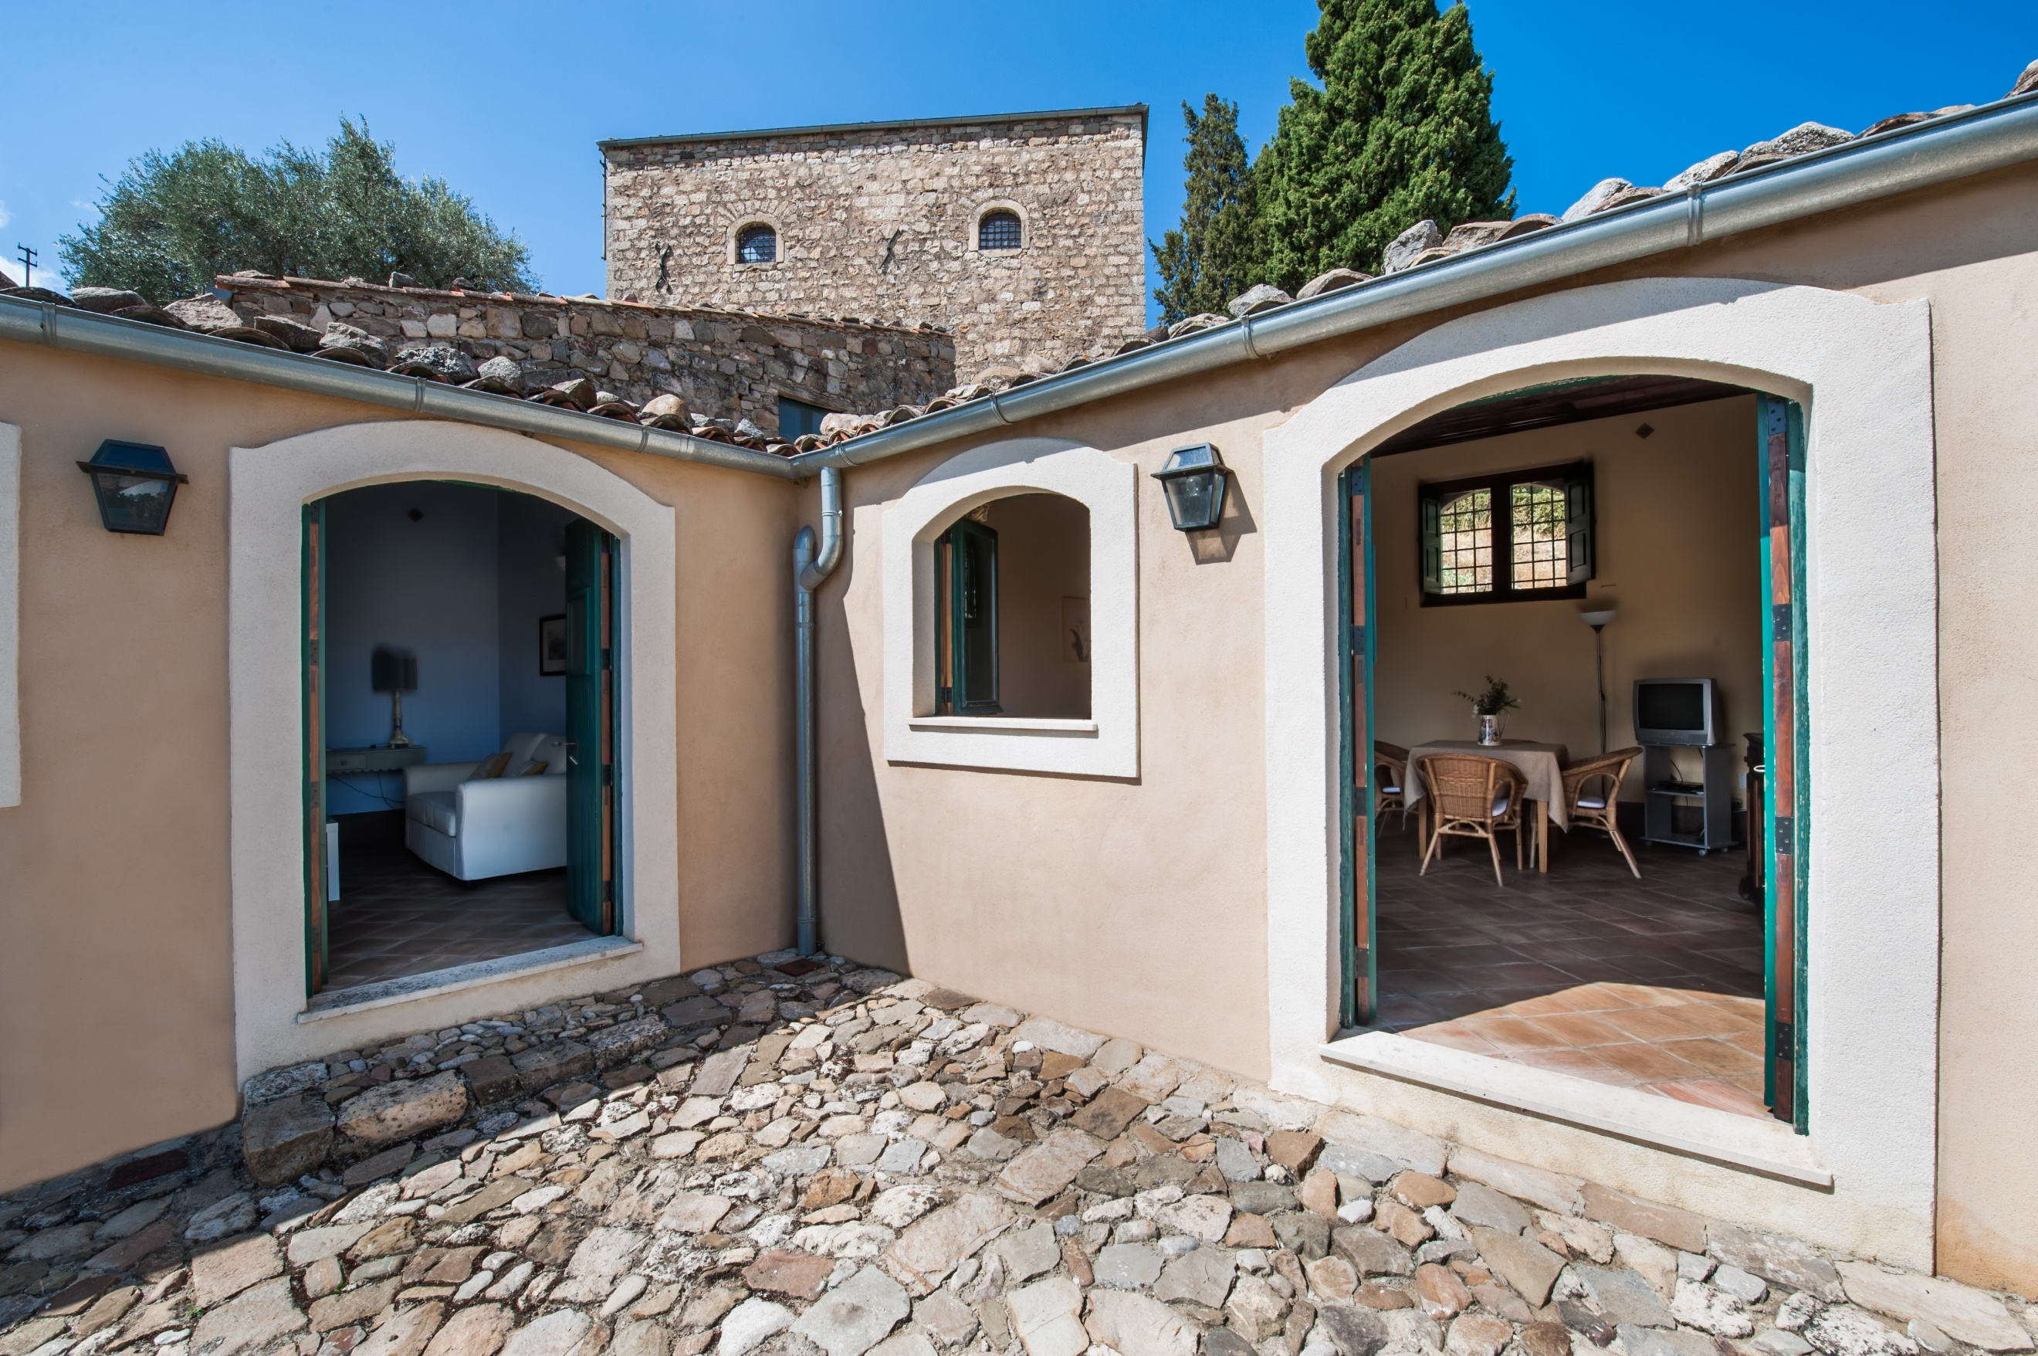

Located in the garden, this suite shares a large, panoramic patio with its twin suite, Conigliera B

It’s composed by one double bedroom, one living room with kitchenette and one bathroom.

**SUITE CONIGLIERA B**

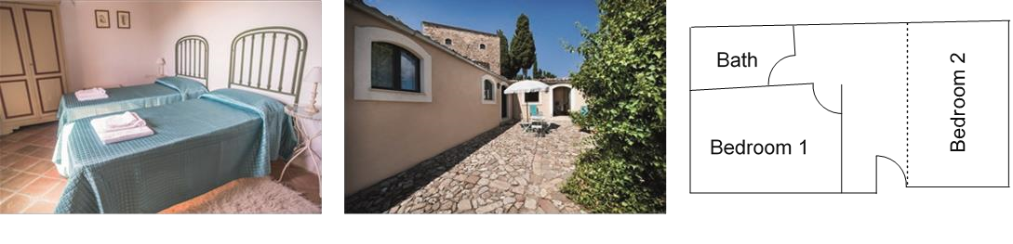



Very similar to her twin apartment, also La Conigliera B offers one double bedroom, one living room with kitchenette and one bathroom.

**ROOMS WITH SHARED BATHROOM**

**LA FORMAGGIAIA**

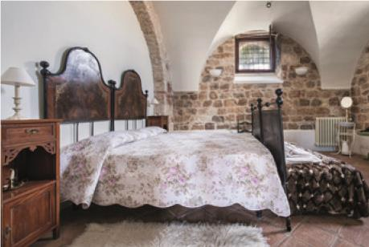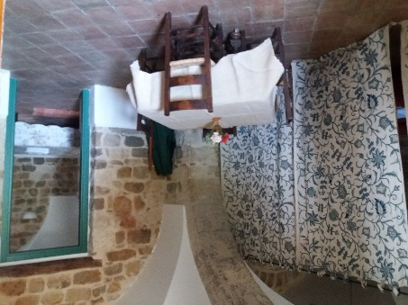

Bedroom

1



Bedroom 2



Living

room



Bath

Decorated with stone walls, the antique cheese warehouse is also 90 sq.m. large. It offers two double bedrooms, one of which closed by curtains, a living room, a bathroom with bathtub. It overlooks the ancient courtyard of the Masseria.

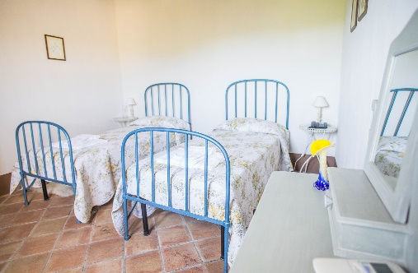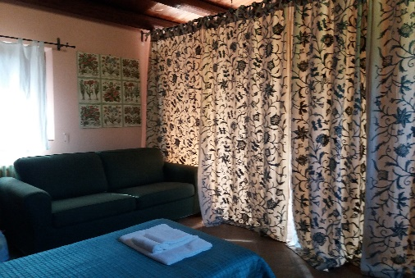

Offering a beautiful view of the swimming pool and of the fields, La Stalletta is a 60 sq.m apartment, two double bedroom, one delimited by curtains, bathroom with bathtub, and a large exclusive patio outside.

**MARCATO**

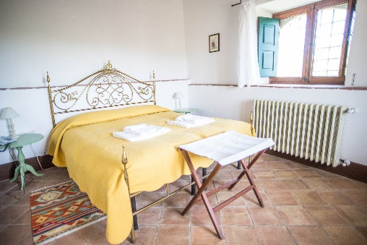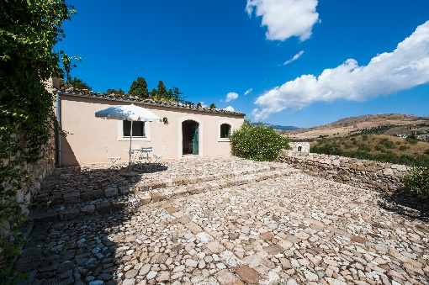

Bedroom 1



Bedroom 2



Bath

The former sheep stable has a very large, private patio with an amazing round view, and it is composed by two bedroom, both with king size or two double beds. One of the bedrooms is delimited by curtains. It has a bathroom with bathtub.